DTOC Task Manager

How to use the new SNAPI Task Manager

This KB will showcase the steps necessary for creating, updating or deleting Tasks using the DTOC Task Manager.

# Login to Remote Desktop

1. Open the start menu icon and run a search for Remote Desktop.
   1. Click on “Remote Desktop Connection”

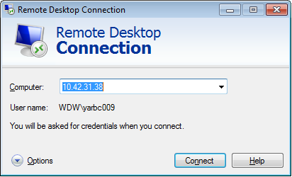

* 1. Enter the IP address of the VM: **10.42.31.38 Click Connect**
  2. You will be asked to provide your individual login credentials. These are the same credentials you use to login to your work station.
  3. Click OK on the access warning screen, you will be connected to the VM.

# Create a new Task

1. Open the DTOC Task Manager located on the desktop. Below is the interface for the tool.

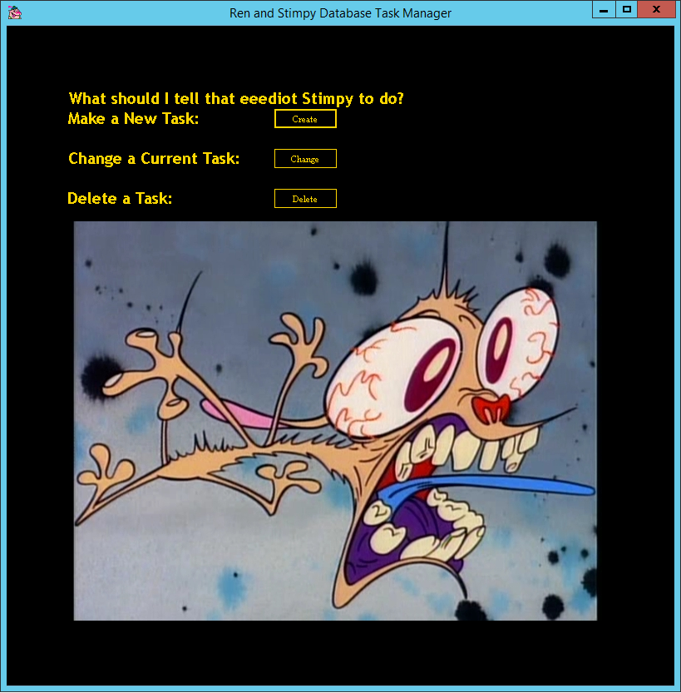

* 1. Click on the create button next to: **Make a New Task: (shown below)**

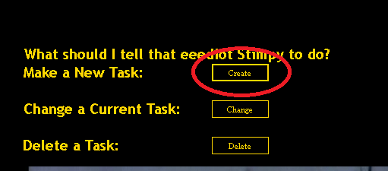

* 1. This will open up the Create Window, it looks like this:

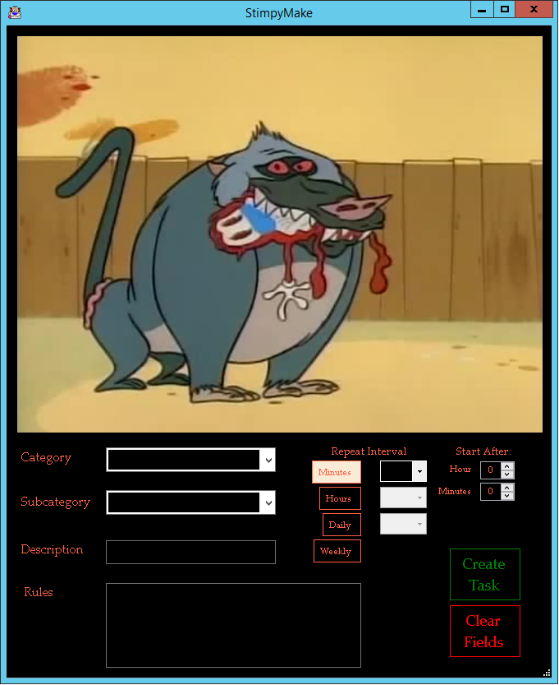

* 1. Using this form you will be able to create a new task that will be sent to Service Now as a Priority 4 incident. **All the fields in the form are required**. They will be explained below:
  2. Category:
     1. Choose from the different items in the dropdown menu that best fits the task you are wanting to create. The choices are: Repair, Install, Update, Remove, Check, Security and Event
        1. For Instance if you needed to create a task to begin Opening Procedures, you would most likely use the Check Category.
  3. Subcategory:
     1. Choose one of the items from the dropdown menu. As with Category select the item that most fits the task you are trying to create. The choices are: Application, Authentication, Availability, Cancellation, Component, Connectivity, Data, Functionality, Performance, Patch, Peripheral, Version, Hardware, Software, Ticket, Alert, and Unauthorized.
        1. Using the example above, the proper Subcategory for beginning Opening Procedures would likely be Application.
  4. Description:
     1. Enter the title of the task here. For example: **Begin Opening Procedures**
  5. Rules:
     1. You can use this field to provide additional information concerning the task. This can be rules on how to complete it or the title of the KB connected to the task.
  6. Repeat Interval:
     1. Select how often you would like the task to be repeated.
        1. Minutes: you can choose between 15, 30 and 45 minute intervals
        2. Hours: you can choose between 1-23 hours
        3. Daily: you can choose between 1-6 days or Weekdays
           1. Choosing Weekdays will send the task to Service Now Mon-Fri.
        4. Weekly, if you choose weekly the task will repeat every 7 days
  7. Start After:
     1. This field can be left at its default of 0, 0. However if you have a specific start time for this item to repeat please choose the 24 hour time for it to start.
        1. Example: if your tasks starts at Midnight, you can leave the hour and minute numbers at the default. If you need the task to start at 6 am, you would set Hour to 6 and leave minutes at 0. If you need it to start at 3:30 PM, you would set Hour to 15 and Minutes to 30.
  8. Clear Fields:
     1. This will erase anything you have chosen from the form.

1. After you have filled out the form click on **Create Task.** If you have filled out everything correctly there will be a message box with the message **“Task Created”**
   1. Click OK and Close the forms if you are finished.

# Change a Task

1. From the Task Manager form click on the button next to **Change a Current Task:**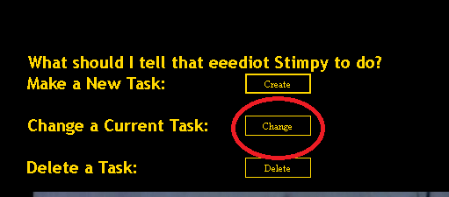
   1. The change task window will open: 
   2. Click on the down arrow located next to **“Choose Task”**
      1. When you click on the dropdown the tool will read from the Database and populate the dropdown will all the tasks currently stored there. *Note: this takes a couple of seconds depending on how many tasks are in the database.
      2. The dropdown uses the Task Description as the items you can select in the dropdown.
   3. Select the task you want to change:
      1. After you click on the Task you want to change the individual fields will populate in the form with the current information associated with the task.
      2. Click on the **“Edit Task”** box
         1. The second half of the form will activate and allow you to choose a new: Description, Category, Subcategory, Rules, Repeat Interval and Start After time. Once again **ALL** fields are required. If you do not want to change this task after all you can click **“Cancel Edit”**
         2. After you enter the new information Click **“Accept Changes”**
   4. Once you have accepted the changes a Message Box will appear with the message **“Task Replaced! Press OK”**
      1. Click OK
      2. If you click on the Choose Task dropdown again, you can confirm the change.

# Delete a Task

1. Click on the delete button next to **“Delete a Task:”**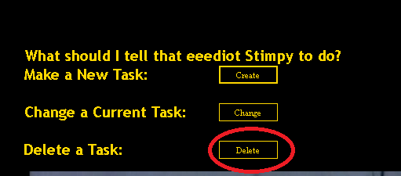
   1. The Delete Task window will open:

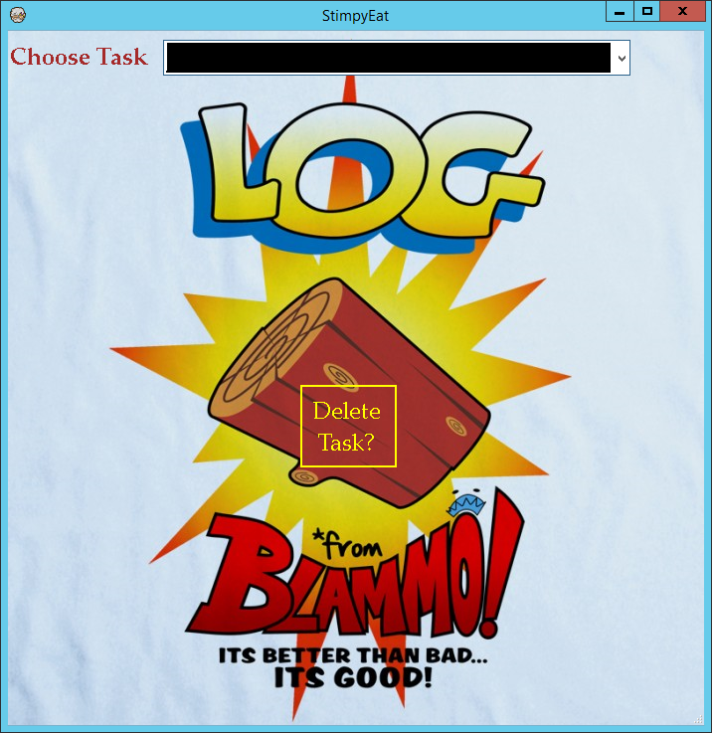

* 1. Click on the **Choose Task** dropdown arrow.
     1. The tool will get the descriptions of all the tasks currently stored in the database. This will take a few seconds and you only need to press the button once.
     2. Select the description of the task you want to delete.
     3. Click **“Delete Task?”**
        1. A message box will appear with the message: “Are you sure that you want to Delete this task?”
           1. Press Yes to delete
           2. Press No to change your mind.
        2. After you press “Yes” another message box will appear confirming the deletion.
           1. You can confirm it further if you click the Choose Task dropdown again after closing the message box.

You can go view a video on the process below:

